MySQL Commands

Contents

Connect to MySQL server 2

SELECT 3

INSERT 4

UPDATE 5

DELETE 6

## Connect to MySQL server

mysql -h xwm-mysql -u admin -p

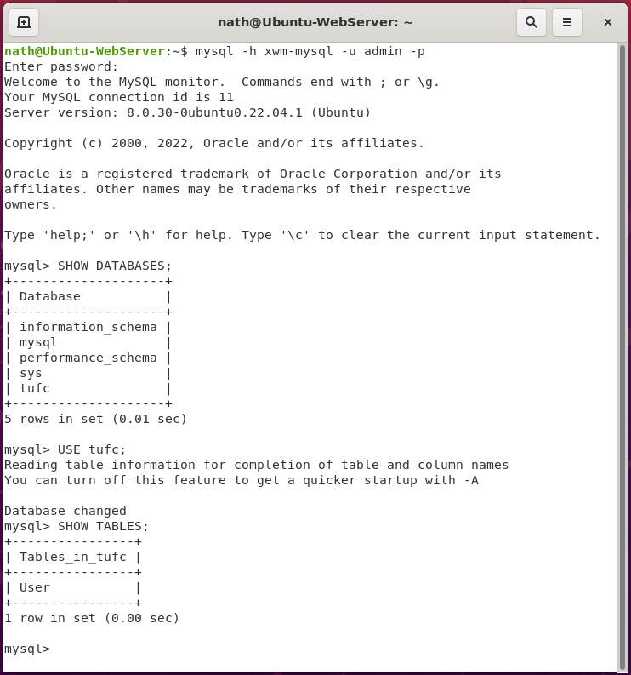

## SELECT

SELECT column1, column2, ...  
FROM table_name;

***or*** SELECT *

FROM User;

#### Example – Select all columns on the ‘User’ table

SELECT userID, firstname, lastname, email

FROM User;

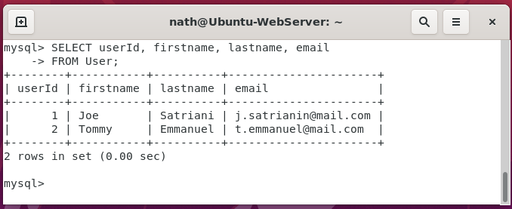

## INSERT

INSERT INTO table_name (column1, column2, column3, ...)

VALUES (value1, value2, value3, ...);

#### Example – Insert ‘Tommy Emmanuel’, in to the table ‘User’

INSERT INTO User(firstname, lastname, email, createDate)

VALUES(‘Tommy’, ‘Emmanuel’, ‘t.emmanuel@mail.com’, NOW());

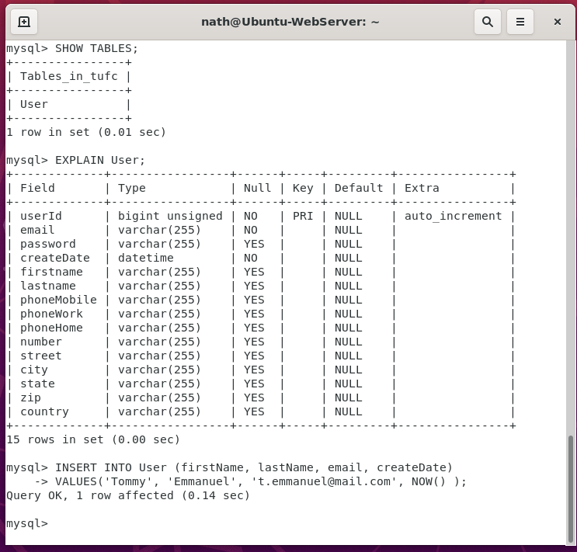

## UPDATE

UPDATE table_name

SET column1 = value1, column2 = value2, ...

WHERE condition;

#### Example – Update ‘Satriani’ in the table ‘User’

UPDATE User

SET email = ‘j.satriani@mail.com’

WHERE userId = 1;

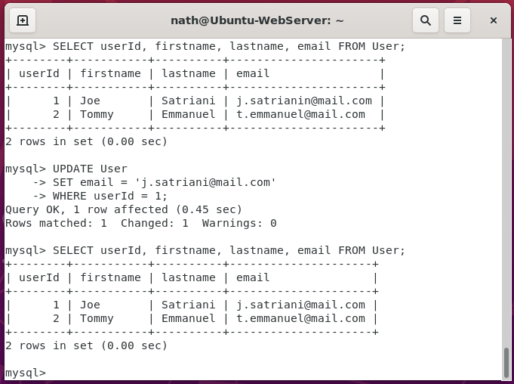

## DELETE

DELETE FROM table_name

WHERE condition;

#### Example – Delete a row, from the table ‘User’

DELETE FROM User

WHERE userID = 3;

